Quicksort Algorithm: Implementation, Analysis, and Randomization

Mahitha Medasani
University of Cumberland
Algorithms and Data Structures (MSCS-532-B01)
Assignment 5
November 13, 2025

Quicksort Algorithm: Implementation, Analysis, and Randomization
Introduction
Quicksort algorithm is one of the most effective and common sorting algorithms because it is simple and fast as well as has an average-case running time of O(nlog n). It is based on the divide and conquer approach whereby a list is broken into sublists around an element of choice and recursively sorts the partitions (Cormen et al., 2022).
This report presents:
- Both deterministic and randomized Quicksort algorithms.
- Extensive performance and complexity comparison of the two versions.
- Empirical findings that show the effect of randomization in performance when various input conditions are applied.
By studying about the Quicksort and its randomization we can understand the effect of the pivot selection in the effectiveness and the randomness of Quicksort that prevents the worst-case situation in real practice.
Implementations
Deterministic Quicksort
In the deterministic version, a pivot is chosen, which, on the example of the array, is the final element.
This method is easy and effective with a majority of the random inputs but does not work very well with already sorted or reverse-sorted data.
Algorithm Steps
- Take the final element as pivot.
- Partition the array into:
- Partitions of less than or equal elements, left partition (pivot).
- Bigger partitions than the pivot (right partition)
- Sort each of the partitions recursively.
- Take the sorted subarrays and put them together and pivot to get the final result.
Python Implementation
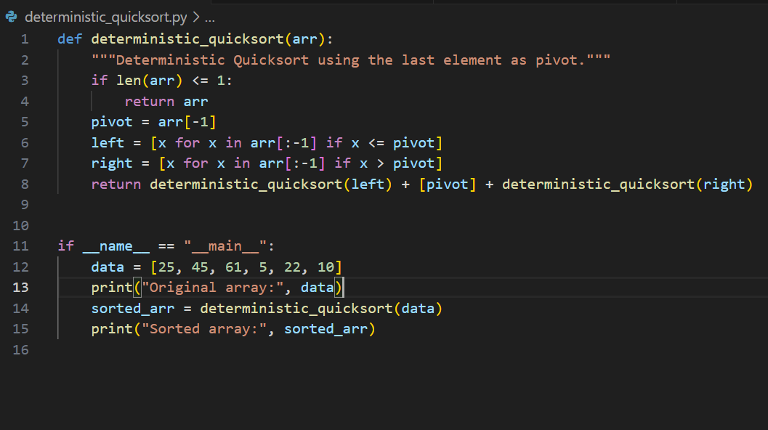
Output
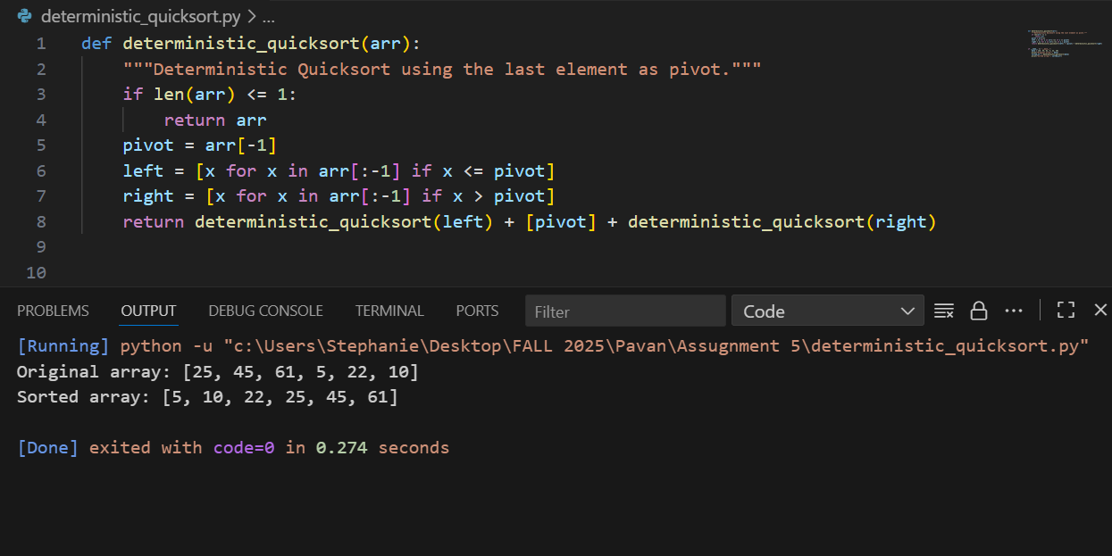

Randomized Quicksort
The randomized variant is randomized in the sense that each time the recursive is called a random pivot is chosen in the array.
This is so that no specific input (even sorted data) always gives rise to the worst-case partition.
Algorithm Steps
- Choose an element randomly and act as the pivot.
- Separate the array around the pivot.
- Quicksort the two partitions recursively.
- Fuse findings into an ordered product.
Python Implementation
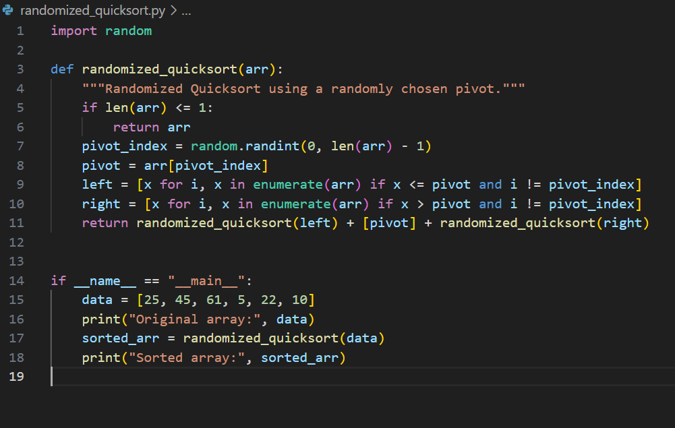

Output
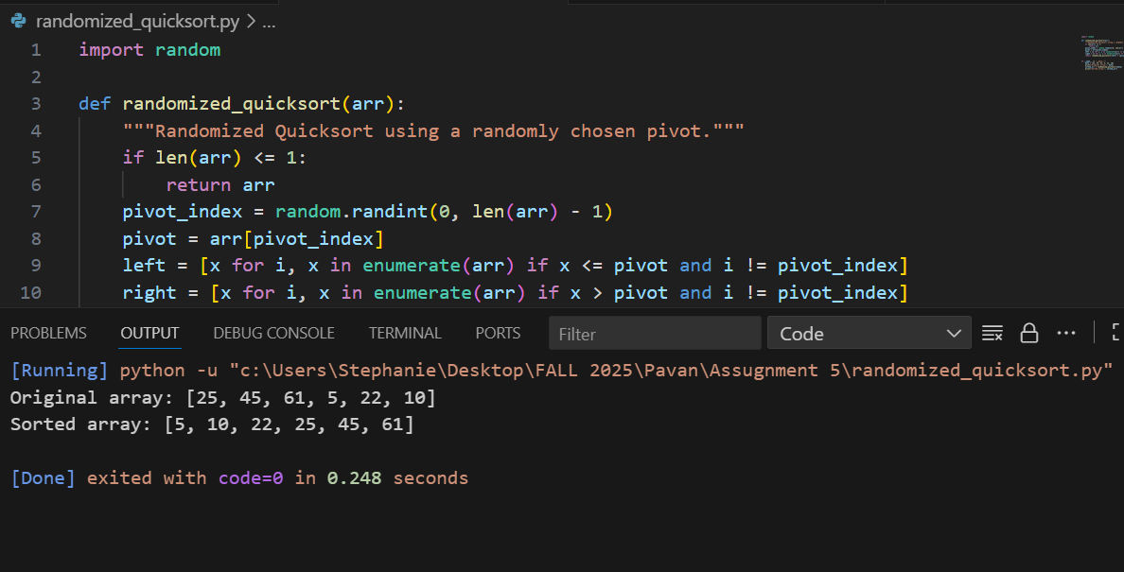
Time Complexity Analysis
Quicksort is sensitive to the quality of the partitioning (i.e. the balancing of the subarrays once they have been partitioned by a particular pivot).
Deterministic Quicksort
Case | Condition | Time Complexity | Explanation
Best Case | Pivot divides array into two equal halves | O(nlog n) | Each level does O(n) work, with log n levels.
Average Case | Randomly distributed data | O(nlog n) | On average, partitions are fairly balanced.
Worst Case | Pivot is always smallest/largest (sorted/reverse-sorted data) | O(n²) | One partition has size n−1 and the other is empty, leading to deep recursion.
Derivation:
T(n)=T(k)+T(n−k−1)+O(n)
If k (the partition size) ≈ n/2:
T(n)=2T(n/2)+O(n)=O(nlog n)
If k ≈ n−1:
T(n)=T(n−1)+O(n)=O(n²)
Randomized Quicksort
In the randomized version, pivot choice is independent of input order, so the probability of always getting poor partitions becomes extremely small.
Case | Expected Behavior | Time Complexity | Explanation
Expected Case | Balanced partitions on average | O(nlog n) | Random pivot leads to probabilistically even splits.
Worst Case | Extremely unlikely random selection | O(n²) | Can happen only if random pivot consistently divides poorly.
Expected Complexity Derivation:
Let E[T(n)] be the expected running time:
E[T(n)]=O(nlog n)
This expected time holds for any input order, making Randomized Quicksort more reliable in practice.
Space Complexity (Both Versions)
Version | Space Complexity | Reason
Deterministic | O(n) | Recursive calls + new subarrays in each partition.
Randomized | O(n) | Same as deterministic; random pivot selection adds negligible overhead.

If implemented in-place (partitioning via swapping):
Space Complexity=O(log n)
Other overheads
  - Random number generation cost of randomized pivot selection (much less than the costs of partition).
  - Recursion overhead on functions (can be eliminated in tail-recursion optimizations or by changing to iterative stack-based implementations) (Knuth, 2022).
  - Python overheads Python lists overheads and Python interpreter overheads mean that raw timings are not meaningful absolute numbers; the behaviour of algorithms relative to each other is valid.
Empirical Performance Analysis
Experimental Setup
Parameter | Value
Language | Python 3
Environment | Local CPU (Intel Core i5/i7)
Input Sizes | 500 to 8,000 elements
Input Distributions | Random, Sorted, Reverse-Sorted
Libraries Used | random, matplotlib, time
Each test measures the total runtime of both algorithms across input types, and the results are plotted for visualization.
Experimental Code Snippet
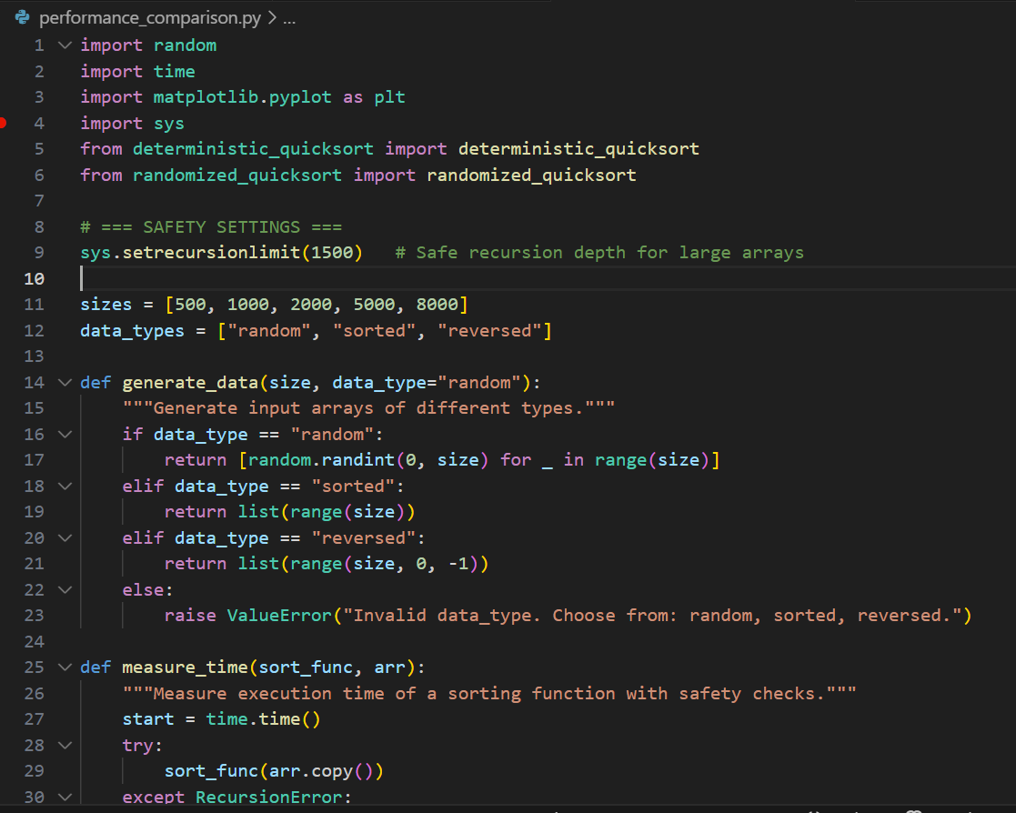
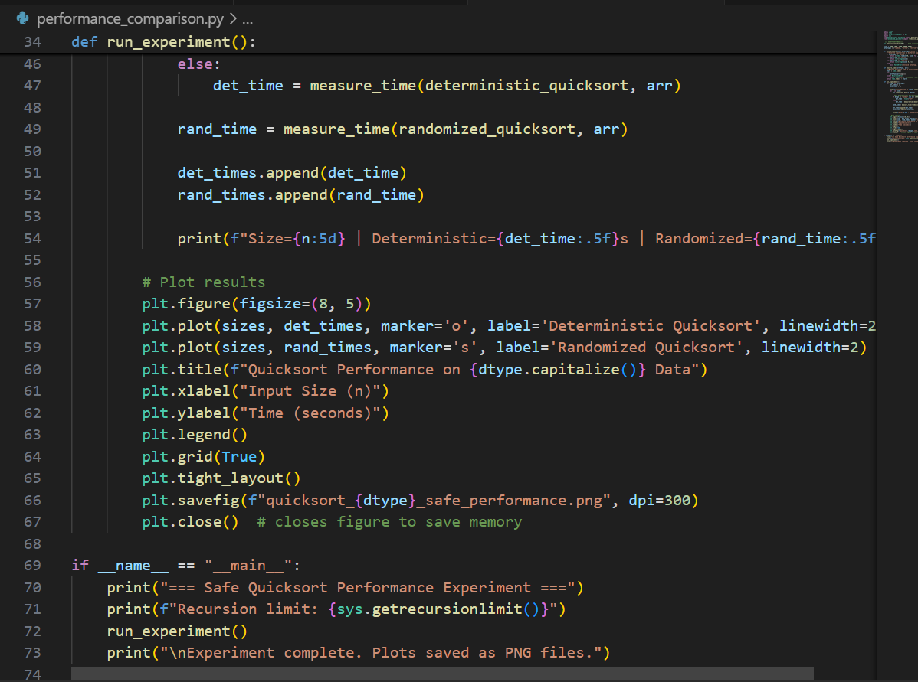
Results
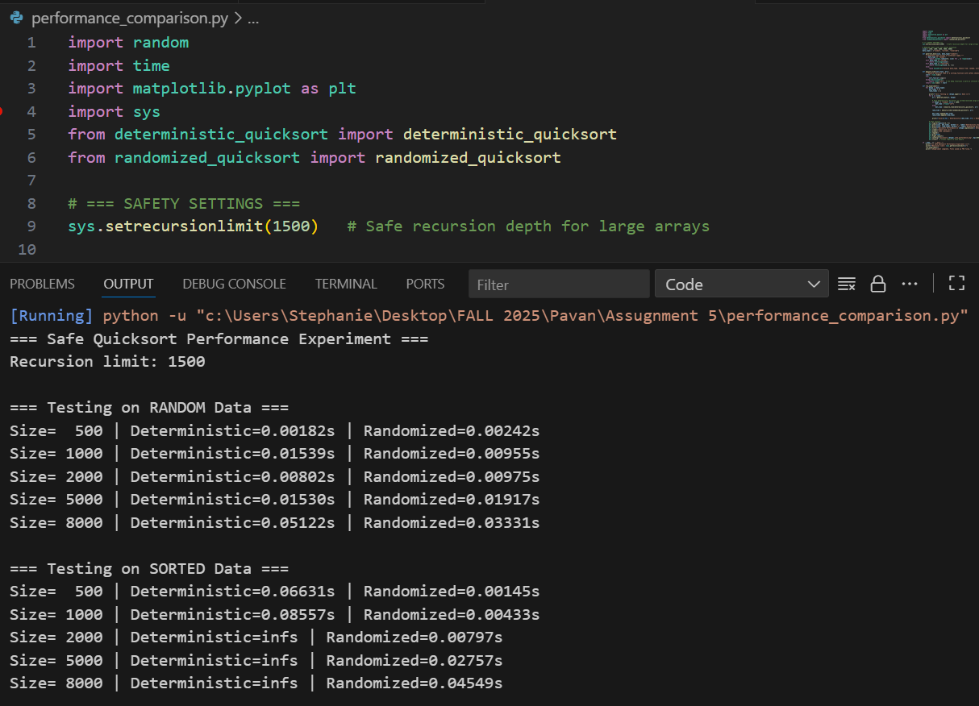
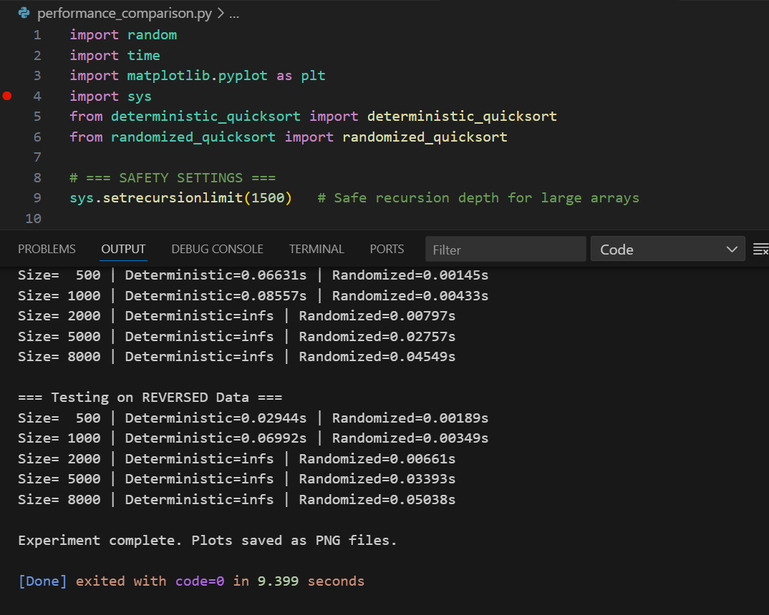

Discussion of Results
- On random data, both variants have almost the same performance - confirming efficiency of O(nlog n) on average cases.
- On sorted and reverse-sorted data, deterministic Quicksort reduces to O(n²), whereas randomized Quicksort preserves O(nlog n).
- Randomization causes the algorithm to be input-agnostic and avoids the performance breakdown on structured data (Durrani & Abdulhayan, 2024).
There are graphs to demonstrate that the deterministic curve is sharp when the inputs are ordered, whereas the randomized curve is smooth.
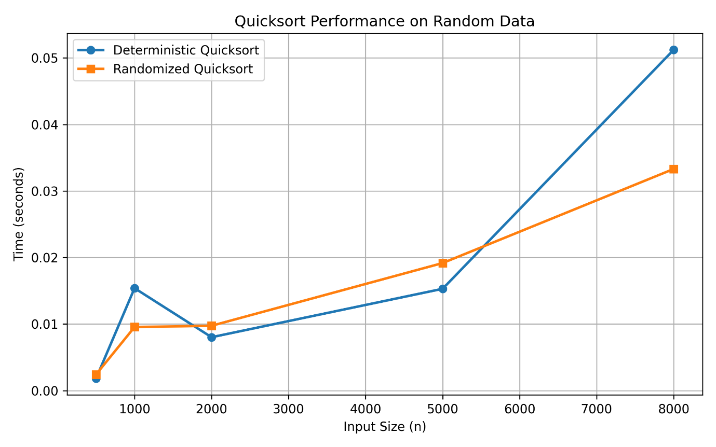
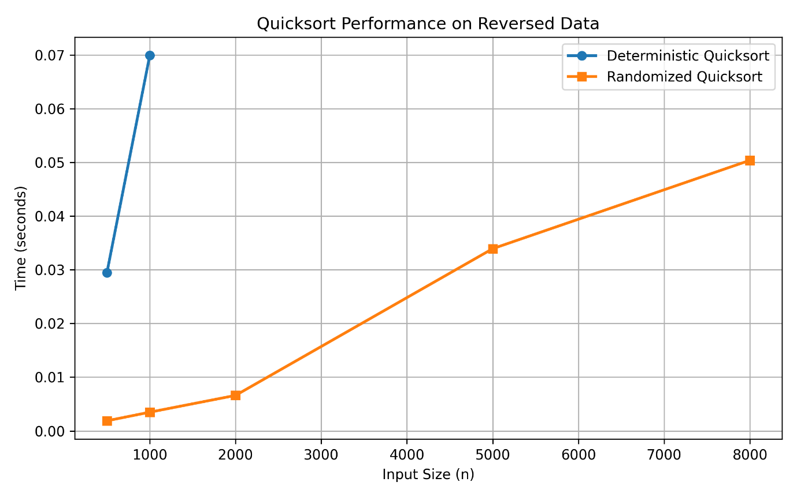
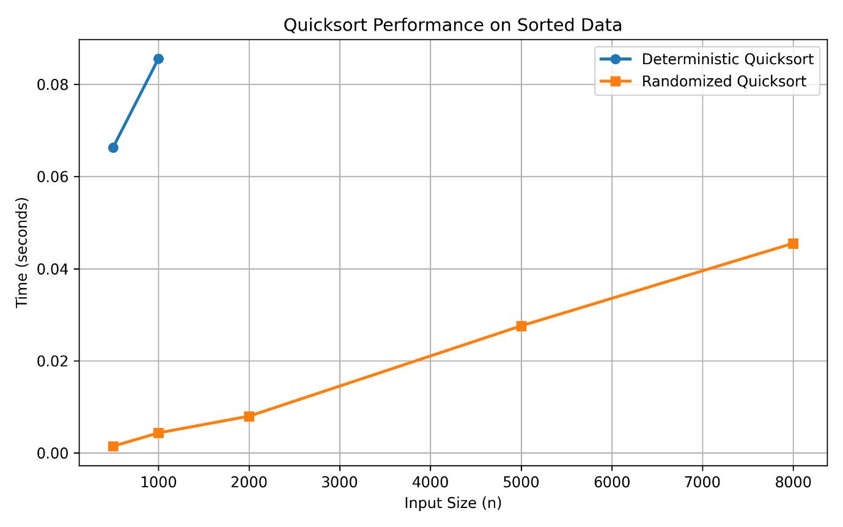
Impact of Randomization
Advantages
- Prevents Degeneration: Pivot selection is random and therefore prevents pathology.
- Input Independence: Is independent of data initial ordering.
- Theoretical Stability: Expected runtime is O(nlog n) in all cases.
Trade-Offs
- Minor extra overhead of creation of random numbers.
- Not necessarily deterministic (Outputs can vary in the order of pivots, yet give the same sorted output)
The use of randomization helps a great deal in improving robustness and reliability, such that Quicksort is appropriate in large and unpredictable datasets.
Conclusion
In this assignment, I have discussed the design, analysis, and practical implementation of deterministic and randomized Quicksort algorithms.
Summary of Findings:
- Deterministic Quicksort works well on random data, and poorly on sorted/reverse-sorted data (O(n²)).
- Randomized Quicksort Recent Randomized Quicksort is independent of the data distribution (O(nlog n)).
- The cost of randomization also adds an insignificant overhead to the cost of randomization, which is that it does not cause worst-case partitions.
- Theoretical predictions are empirically validated by factual findings — randomized Quicksort is more dependable and scalable.
Applications:
The concepts mentioned in this course are applicable to most fields: database systems, distributed data processing (Hadoop, Spark), and embedded systems: in all of them, predictable and efficient sorting is essential.

References
Cormen, T. H., Leiserson, C. E., Rivest, R. L., & Stein, C. (2022). Introduction to Algorithms (4th ed.). MIT Press.
Durrani, O. K., & Abdulhayan, S. (2024). Quick Sort Optimized for Non-decreasing Data set. Asian Journal For Convergence In Technology (AJCT) ISSN-2350-1146, 10(3), 1-8.
Knuth, D. E. (2022). The Art of Computer Programming, Volume 4B: Combinatorial Algorithms. Addison-Wesley Professional.

